Practical 4: Library Book Reservation System for SIMATS Library using Cloud Service Provider (SaaS)
Aim
To create a simple cloud-based Library Book Reservation System for SIMATS Library using a Cloud Service Provider to demonstrate the Software as a Service (SaaS) model.
Procedure
- Log in to the Cloud Service Provider.
- Create a new cloud application.
- Design a book reservation form with fields such as Book ID, Book Title, Author, Student Name, Registration Number, Department, Issue Date, Return Date, and Book Status.
- Store book details in the cloud database.
- Configure forms for adding, updating, deleting, and searching book records.
- Test the application by reserving books using sample student details.
- Verify that the reservation details are stored in the cloud.
- Publish the application to demonstrate SaaS.
Implementation

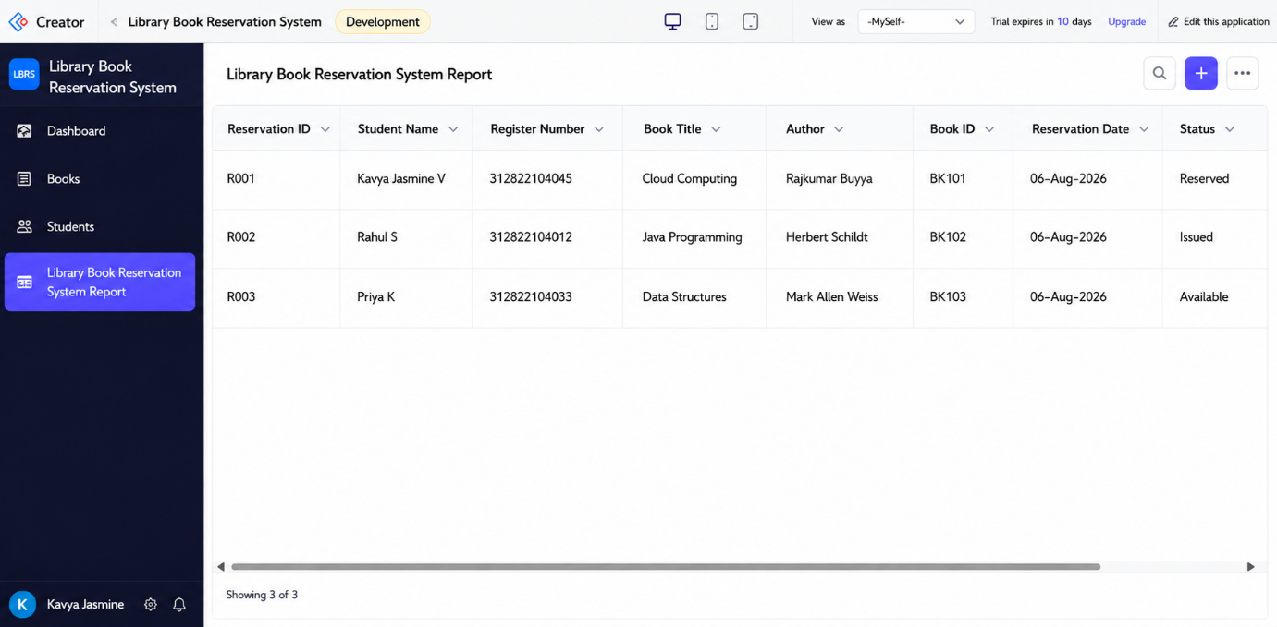
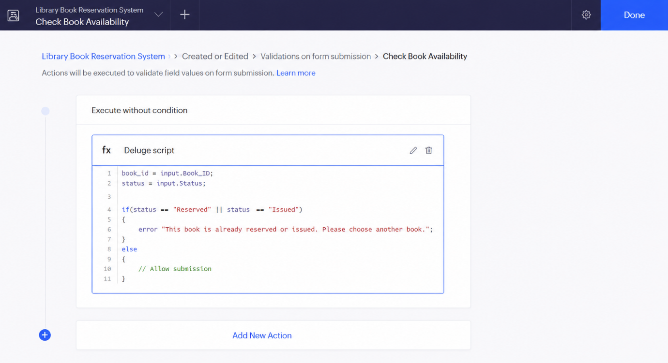
Result:
The Library Book Reservation System for SIMATS Library was successfully created using Zoho Creator as a cloud-based SaaS application. The workflow validates book availability before reservation, ensuring only available books can be reserved. The reservation details are stored in the cloud, and the objective was achieved successfully.

